This one map explains the entire worldwide economy

One Diagram That Will Change the Way You Look At the US Economy
21 July 2015
The US is by far the largest economy in the World, with a nominal GDP of $17.4 trillion in 2014. However, it is not the World leader in all economic sectors: the US is a service-based economy, with a smaller focus on agriculture and industry than other countries (though its industrial and agricultural sectors are still the second- and third-largest in the World due to the sheer size of the US economy).
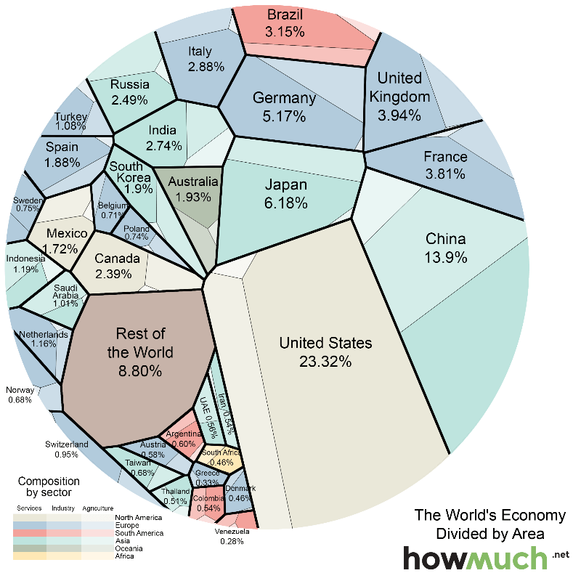
The graphic above (Voroni diagram) represents the relative size of each country’s economy in terms of nominal GDP: the larger the area, the larger the size of the economy. The areas are further divided into three sectors: services, industrial, and agricultural. The US economy is mostly composed of companies engaged in providing services (79.7% compared to the global average of 63.6%), while agriculture and industry make up smaller-than-average of portions of the economy (1.12% and 19.1% compared to averages of 5.9% and 30.5%).
The next largest economy, China, is roughly balanced between industry and services (though the service sector is growing at a faster rate), with a 9.1% contribution from agriculture. In this sense, China is a bit of an anomaly: other rich countries have service sectors that greatly outweigh both industry and agriculture. Over the past several decades, China has leveraged its competitive advantage and designed industrial policies to incent manufacturing in the country. But as China grows, it will continue to transition to a service-based economy. Similarly, India will see a decrease in agriculture’s contribution to its GDP and an increase in the size of the service sector.
Over time, the service sectors of developed nations have tended to grow relative to the other sectors. But are there limits to this trend? What is the natural size of each sector?

