Why is so much wealth hidden? Failed democracy.
- by Marshall Steinbaum Posted on September 22, 2015
This morning, the Washington Center for Equitable Growth is hosting a discussion with University of California-Berkeley economist Gabriel Zucman about his important new book, “The Hidden Wealth of Nations.” Using new data, Zucman documents that eight percent of global financial wealth is held in offshore tax havens, with the majority of that hidden wealth held by wealthy people living in the world’s leading economies.
When this hidden wealth is taken into consideration, many so-called global imbalances go away. The idea that China owns the United States, for example, turns out to be a myth. The answer to “who owns the United States?” is, overwhelmingly, rich people, both in the United States and abroad. But that ownership is masked in foreign bank accounts, out of the reach of domestic tax authorities and statisticians.
The problem is worse in Europe, where tax havens such as Luxembourg and Switzerland are even more embedded in the regional financial system than are the Cayman Islands and the Bahamas in the U.S. context. And tax havens hiding private wealth are absolutely pervasive when it comes to the oligarchies of Russia, China, and the Middle East.
It’s worth noting that few economists would support the existence or proliferation of tax havens. By reducing the capital tax base, tax havens increase the effective tax rate on the capital that remains within the reach of tax authorities, creating a distortion that, in principle, reduces everyone else’s incentive to amass wealth. Those savvy enough to open a Swiss bank account generally have a lot more at stake than ordinary savers. Thus, tax havens impair both efficiency and equity.
Zucman proposes several policies for dealing with tax havens—first and foremost, to create a public database of the ownership of registered securities (stocks, bonds, and other financial instruments) based on central depositories currently in private hands. As a technical matter, that is straightforward, but it is still radical: the nationalization of quasi-administrative data for the public benefit.
We already do that for the property and housing market in the United States, where all tax assessments are available to the public, and more up-to-date market values for housing wealth can be found on websites such as Zillow. Doing the same for financial wealth is straightforward, but it would challenge the interests of an even wealthier demographic: those who own securities, as opposed to housing.
Zucman further proposes to move to a global apportionment system for corporate taxation. Corporate use of tax havens differs from individuals because the existence of corporate stash-houses isn’t hidden from authorities. Instead, they are simply built in the places with the lowest corporate tax rates, regardless of where the company conducts substantial business operations. Under the system Zucman proposes, companies would add up their global profits and then pay taxes in different jurisdictions depending on some formula that “apportions” profits—for instance, the share of employment or of sales (or a combination of factors) in each jurisdiction. The United States already does that for corporate taxation in different states, so it is technically feasible in principle but would require international cooperation.
But if the economics is so clearly against tax havens and the policy solutions are straightforward, then how did we get to where we are? The answer is not that a few villainous, self-serving countries act as parasites on the world economy by offering rich people a way out of their responsibilities. Unfortunately the situation isn’t that straightforward.
In fact, U.S. policymakers tacitly encourage the proliferation of tax havens and the chicanery that enables rich people and corporations to stash their money beyond the reach of the Internal Revenue Service (with a few notable exceptions, including the Foreign Account Tax Compliance Act of 2010). Even now, Congress is debating a “Repatriation Holiday,” which would allow companies who strategically book large profits at overseas subsidiaries to avoid corporate taxes by returning their cash stockpiles to their U.S. shareholders. Even talking about such a policy furthers such tax avoidance, since it signals to companies that they won’t have to pay up if they hold out long enough.
Speaking of Luxembourg, Zucman writes, “Starting in the 1970s, the government initiated an unheard-of enterprise: the sale to multinationals throughout the world of the right to decide their own rate of taxation, regulatory constraints, and legal obligations for themselves.” In other words, companies get to choose their own tax rates by strategic use of low-tax jurisdictions to earn profits and conduct some of their operations, and wealthy individuals do as well. That is not a privilege available to ordinary citizens. But the trend has been mimicked everywhere, directly by authorities in havens and indirectly by those in productive economies who tolerate them.
Moving beyond tax havens in particular, the ideological justification for low and falling rates of taxation on capital is the Chamley–Judd Theorem, which “proves” that the optimal tax rate on capital is zero in the long run. According to the theorem, anything more destroys the incentive to save and thus the productive capacity of the economy. That is why, the same thinking goes, even workers who don’t own any capital should prefer zero taxes on capital. Whatever its theoretical merit–and recent research suggests it doesn’t have much–the intellectual influence of the theorem has been strong. In the United States, as in most countries, the individual tax rate on capital is below the income tax rate precisely in order to incentivize people to save, and recent proposals involve eliminating capital taxes altogether for that reason.
Why is the Chamley-Judd result relevant to international tax havens? Unfortunately for the rich, public sentiment is not always as enlightened as mathematical economics, especially in the voting booth, and the possibility exists that a dangerous capital-taxing radical might sweep to power. That “threat” can be neutralized if the wealthy avail themselves of tax havens. All of this is part of the larger trend among policymakers to be too credulous about formal “optimal policy” results in theoretical economics.
But the worse tendency is to enshrine those theoretical results in the policymaking apparatus at the expense of democratic control. Besides optimal capital taxation and tax havens, a second example of that anti-democratic dynamic at work is the European Union’s macroeconomic policymaking in the aftermath of the Great Recession and the ongoing crisis in Greece. The notion is that democratically elected leaders might give way to voters’ misguided populism and enact irresponsible policies, whereas sound macroeconomic management requires exacting great pain from the workforce and the electorate in the form of fiscal austerity. Thus, the only way to ensure sound policymaking is to hand over power to unaccountable transnational elites—in the case of the Eurozone crisis, those would be the European Commission, the European Central Bank, and the International Monetary Fund.
A third example is the outsourcing of environmentally harmful industries to developing countries—as discussed in Erik Loomis’s excellent recent book “Out of Sight”—where elites are even more beholden to polluters than in the rich world. Outsourcing allows job-creating businesses to avoid the supposed scourge of populist over-regulation. In effect, they choose their own (lax) regulatory environment, just as Zucman writes about in his analysis of tax havens.
Subverting democratic control of economic policy is a big reason why inequality has gotten so high across the developed world. Zucman’s book carefully documents the result in the case of tax havens, but the lesson is far more general: Inequality is high because of past inegalitarian choices that policymakers have made, and we must revisit those choices if we’re to address inequality going forward.

REAL TIME ECONOMICS

Sep 28, 2015

Is Wealth Inequality Hidden in Tax Havens? Piketty’s Co-Author Thinks So

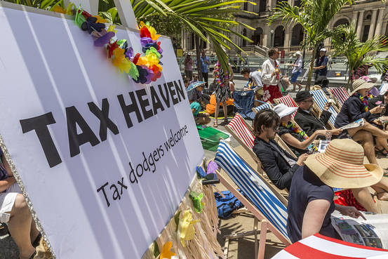
Demonstrators held a mock tax haven event in Brisbane, Australia, last year, calling on Group of 20 nations to crack down.
GLENN HUNT/GETTY IMAGES
The idea of stashing money in a Swiss bank account or some Caribbean island sounds a bit antiquated—the act of a 1960s James Bond villain. But the amount of wealth flooding into tax shelters around the world may in fact be rising to unprecedented levels.
The economist Gabriel Zucman, a protégé and co-author of the French economist Thomas Piketty, has published a new book that attempts to document money hiding out in tax havens. Mr. Zucman’s book, “The Hidden Wealth of Nations,” documents just how dramatic the recent rise has been.
To estimate the amount of hidden money, Mr. Zucman begins with a simple trick. If you add up all the financial liabilities and all the assets in the world, they ought to balance. One person’s liability ought to be another’s asset. (Or one company’s, one country’s, etc.) But if you add up all the world’s reported liabilities, the figure is about $6 trillion higher than the reported assets—a sum that’s been growing. The likeliest explanation: around $6 trillion in assets are being hidden.
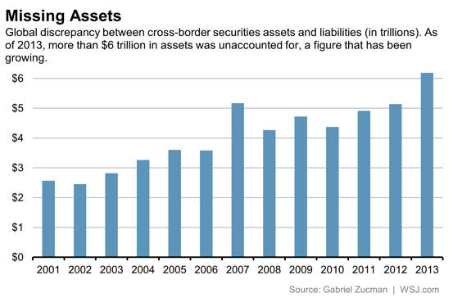
Mr. Zucman has delved into the world’s byzantine financial accounts data and unveiled a wealth of information (much of it available on his website) that documents the extent of this rise. For example, he finds a rapidly growing share of U.S. equities are being managed offshore.
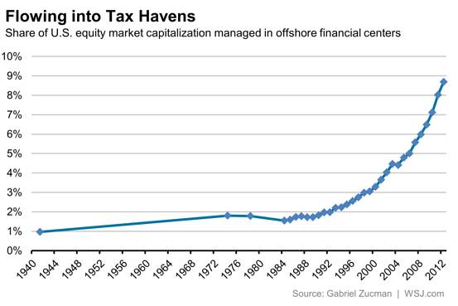
The U.S. Treasury did not conduct a regular survey on foreign portfolio liabilities until 1984. But a one-off survey in 1974 showed little rise compared with a survey in 1941. Beginning in the 1990s, however, the share began to rise, accelerating in the 2000s.
And the challenges posed by tax havens are not simply limited to wealthy Americans trying to hide from the Internal Revenue Service. Mr. Zucman finds, for example, that the international profits of U.S. corporations are increasingly showing up in tax havens.
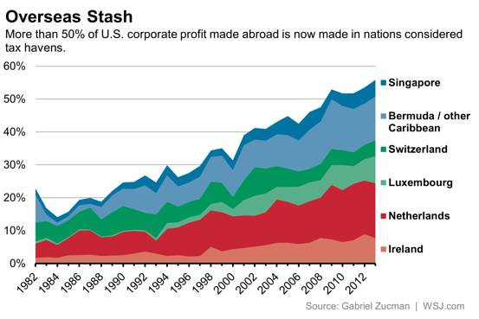
While the official U.S. corporate tax rate sits at 35%, U.S. corporations are increasingly able to manage a lower effective tax rate due to profits booked in low-tax jurisdictions overseas.
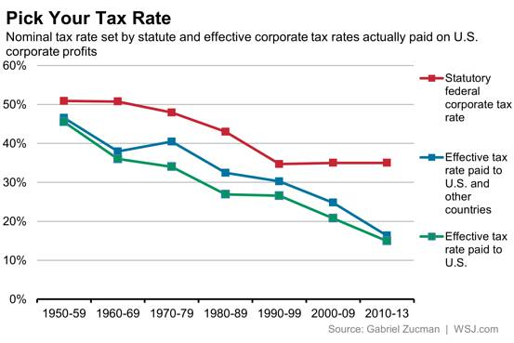
Mr. Zucman seems to have little ambivalence about how to interpret the data, as his book is subtitled “The Scourge of Tax Havens.” He acknowledges that some view tax havens as perfectly legal and legitimate. But whatever the politics, for anyone who cares about understanding the economy, it’s clear a dramatic shift is under way.

