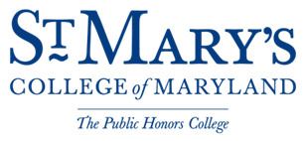

Capital Design Advisory Committee
Wednesday, April 25, 2018

Blackistone Room, Anne Arundel Hall; North Building
St. Mary’s College of Maryland
St. Mary’s City, Maryland
7:30 p.m.

AGENDA

- Maryland Dove Pier Replacement
- Replacement of the Maryland Dove
- Leonard Calvert House

- Maryland Historic Interpretive Center

- Margaret Brent Pavilion

- Chancellor’s Point and Sailing Center Chesapeake Partnership

- New Academic Building and Auditorium

- Jamie L. Roberts Stadium

- Trinity Church Road Sidewalk Update

