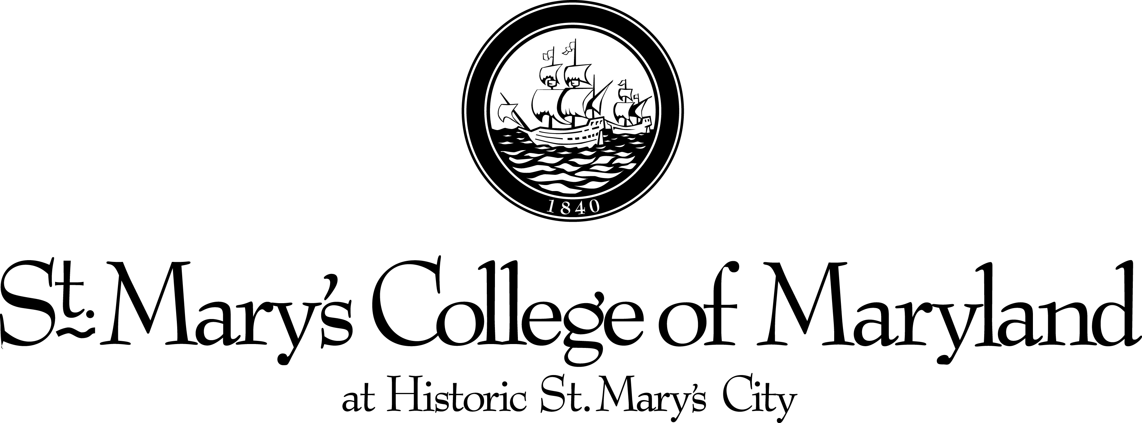

Office of International Education

APPLICATION FOR DS-2019 (formerly IAP-66) FOR EXCHANGE VISITOR (“J” VISA)

Please fill out the entire application. You must also attach proof of financial ability either in the form of an official fellowship, grant or scholarship notification including dollar amount and type, or, if privately financed, a bank statement. If using a bank statement, it must be less than six (6) months old, and contain a dollar amount. The minimum is $14,000 per year.

FULL NAME:
 |  |  |  |  |  | (LAST) |  |  |  |  |  |  |  |  |  |  |  |  |  |  | (FIRST) |  |  |  |  |  |  |  |  |  |  |  |  |  | (MIDDLE)
SEX: |  |  | DATE OF BIRTH: |  |  |  |  |  |  |  |  |  |  |  |  |  |  |  | PLACE OF BIRTH:
 |  |  |  |  |  |  |  |  | (month/day/year) |  |  |  |  |  |  |  |  |  |  |  |  |  |  |  |  |  |  |  |  |  |  | (city, state and country)
LEGAL RESIDENT OF:
 |  |  |  |  |  |  |  | (city) |  |  |  |  |  |  |  |  |  |  |  |  |  |  |  |  | (state) |  |  |  |  |  |  |  |  |  |  |  | (country)
Citizen of what country:
Current Position in Home Country:
Current Mailing Address:
Appointment Type (Ex: Research Fellow):
Department:
Proposed Dates of Stay: From: |  |  |  |  |  |  |  |  |  |  |  |  |  |  |  |  |  |  |  |  |  |  |  |  |  |  |  | To:
 |  |  |  |  |  |  |  |  |  |  | (month/day/year) |  |  |  |  |  |  |  |  |  |  |  |  |  |  |  |  |  |  |  | (month/day/year)
SMCM Salary for this Time Period:
Is this person a new Exchange Visitor |  |  |  |  |  |  |  |  |  |  |  |  |  |  |  |  |  |  |  |  |  | or a transfer from another program |  |  |  |  |  |  |  |  |  |  |  |  |  |  |  |  |  |  | ?
If Exchange Visitor is a transfer from another program, please attach a copy of all DS-2019 forms.
Work address after Arrival: |  |  |  |  |  |  |  |  | 18952 E. Fisher Road
 |  |  |  |  |  |  |  |  | St. Mary’s City, Maryland 20686-3001
Work Phone Number After Arrival:
Principal Investigator or Contact Person:
Name: |  | Mandy Reinig
Campus Address: |  |  |  |  |  |  | Office of International Education 18952 E. Fisher Road, St. Mary’s City, MD 20686-3001
Phone: |  | 240-895-4202 |  |  |  |  |  |  | Fax: |  |  |  |  | 240-895-4463 |  |  |  |  |  |  |  |  |  | E-mail: |  |  |  |  |  | arreinig@smcm.edu
Send completed DS-2019 to: (Check One): |  |  |  |  |  |  |  |  |  |  |  |  |  |  |  |  |  | Exchange Visitor |  |  |  |  |  |  |  |  |  |  |  |  |  |  | or PI/Contact Person |  |  |  |  |  |  | X

