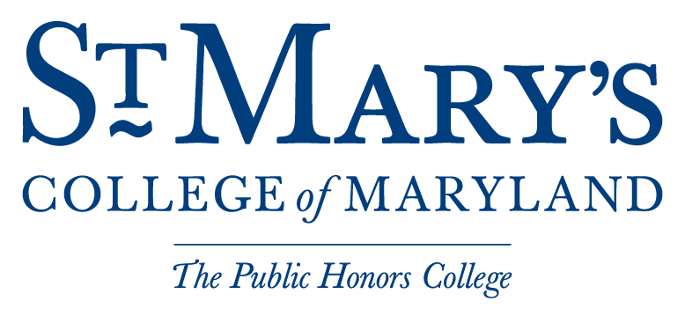
The Green St. Mary’s Revolving Fund (GSMRF)
Application Guide
Thank you for your interest in the Green St. Mary’s Revolving Fund (GSMRF). This document is intended to help prepare you during the application and review process.
Introduction
GSMRF (pronounce “gee-smurf”) was created in the spring of 2010 by the Student Government Association. GSMRF aims to finance on-campus projects that promote environmental stewardship and fiscal responsibility; as such, all GSMRF projects must demonstrate a quantifiable return on investment.
The Basics
Eligibility: All members of the college community are eligible to propose projects. Students are strongly encouraged to have an advisor (possibly a faculty or staff member) or pre-arranged project overseer.
Loan Uses: GSMRF funding will be awarded to projects that 1) improve campus sustainability and 2) save the college money, most commonly through a return on investment (ROI) payback. For example, GSMRF funds might be used to improve fuel, electricity, water, building maintenance, storm water, recycling, composting and other infrastructure to reduce the use of energy and resources and the production of waste. Funds awarded to a project can be used for:
- Materials or Products
- Professional Work and Installation
- Research or Monitoring Equipment
- Employment Opportunities – The board may approve a salary by consensus –preferably for a student employment position –should conditions merit the added cost still yields cost-savings to repay GSMRF.

Project Parameters: Projects must have a realistic and defined payback period. If at all possible, exact cost-savings measurements should be obtained, but an educated estimate can be used if necessary.
Payback Methods: There are two payback options for GSMRF to recoup its costs: cost savings can either be shared 50-50% between the GSMRF and the College until 125% of the initial cost is repaid, or 90-10% between GSMRF and the College until 110% of the initial cost has been recovered. After either 125% or 110% of the cost of the project is recouped by the fund, all savings from cost avoidance will go to St. Mary’s College.
Loan Fund Balance: In any given year, the amount of funding for loans must be 50% less than the standing budget of available GSMRF funds. For 2010-2011, this amount is roughly $40,000. Please remember that no project is too small for consideration!
Application Process
You have a great idea for a sustainability initiative on campus, and have heard that you may be able to get your project supported by GSMRF. However, before you begin filling out your proposal and seek funding, please follow these steps to determine whether your project is feasible on campus:
- Contact the Sustainability Fellow (sustainability@smcm.edu). The Fellow is there to assist you in the proposal process and works to coordinate planning and implementation of projects. To give the Fellow some starting information about your project, fill out and send the initial project proposal form.
- Consult with the Sustainability Fellow (and your advisor if applicable) to identify what your project will entail, what offices or student organizations need to be involved in the planning and implementation stages, and whether alternative or matching funding exists for your project.
- Compile final cost and payback estimates for your project.
Once these steps are done, you can begin the formal project proposal form. Please email the completed application to the Sustainability Fellow (sustainability@smcm.edu) and Mary Grube (mkgrube@smcm.edu), Assistant Project Manager and Fiscal Administrator. The GSMRF Oversight Board must meet at least twice a semester, but they encourage project proposals to be sent before the last month of the semester so that there is ample time to schedule meetings and begin implementation efforts for approved projects.

