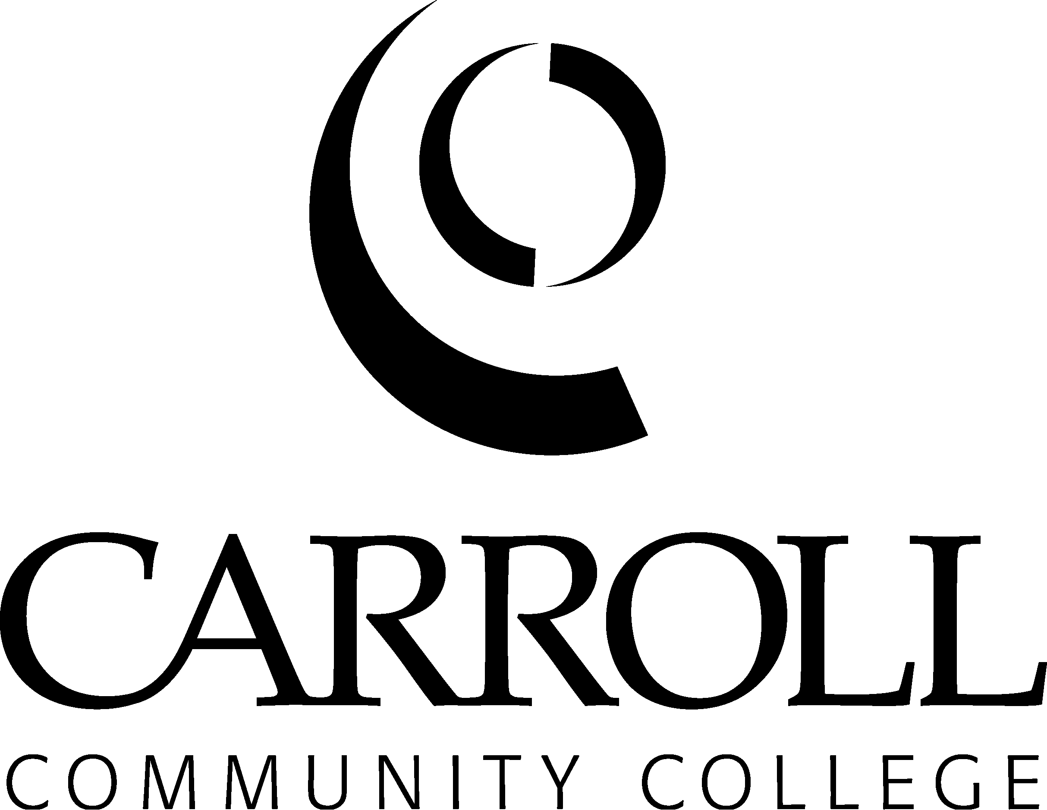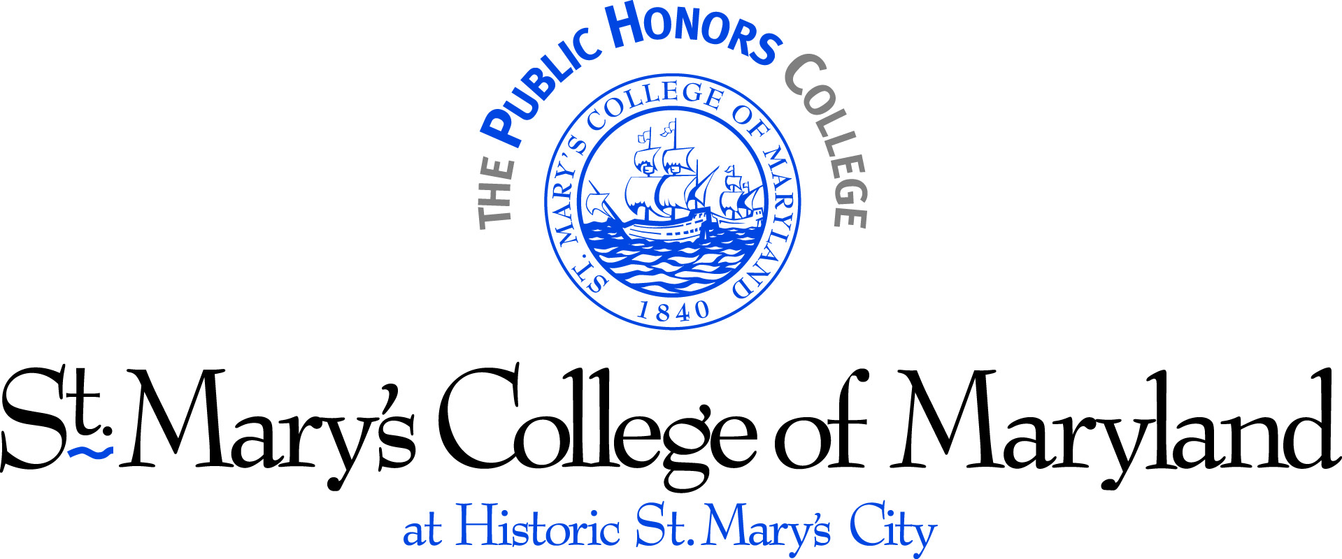

Articulation Agreement
Carroll Community College and St. Mary’s College of Maryland

Carroll Community College (Carroll) and St. Mary’s College of Maryland (St. Mary’s) establish the following articulation agreement to facilitate the smooth transfer of students between these institutions. Normally the educational goals of students are best served when students receive an Associate of Arts (A.A.) or Associate of Science (A.S.) degree from Carroll before enrolling in a full-time course of study at St. Mary’s College. The arrangements are conditioned by the following agreements.

- Students enrolled at Carroll in good standing and pursuing an A.A. or A.S. must petition and follow the procedures developed and approved by Carroll and St. Mary’s to participate in the concurrent admissions program. Both institutions will identify and advise students of the potential benefits of the program. To be eligible for the dual-admission program, prospective students must have a cumulative grade-point average of 3.5 or higher and must have completed at least 21 credit-hours of General Education courses.

- Students must complete all components of the St. Mary’s application for admission, including permission for Carroll and St. Mary’s to exchange registration and grade information.

- Students accepted into the dual-admission program will be admitted to St. Mary’s upon their request in the semester following completion of all degree requirements from Carroll and successful completion of the requirements of this articulation agreement, including earning an A.A. or A.S. degree with at least a 3.5 cumulative grade-point average. Dual-admission students who do not meet the requirements will be considered for admission to St. Mary’s by requesting that their application be reviewed along with all other transfer applicants.

- The Hill Scholars program is an especially strong preparation for study at St. Mary’s. All credits earned in the Hill Scholars general education curriculum will transfer to St. Mary’s. Courses completed outside general education will be articulated based on the academic major. The application fee is waived for Hill Scholars.

- To assure a seamless transition, Carroll and St. Mary’s commit to developing a joint advising and mentoring program for concurrent admission students including an articulation of Carroll course work that will satisfy general education requirements in accordance with COMAR regulations and major requirements at St. Mary’s. It is understood that some majors at St. Mary’s require specific courses at the lower level—courses that may not have been included in the student’s course of study at Carroll.

- For purposes of tuition, financial aid, student governance, and housing, students shall be considered Carroll students until the time of transfer or until they earn their associate’s degree, and become St. Mary’s students thereafter. Students transferring to St. Mary’s will be considered for financial aid, housing, and other services available to St. Mary’s students at the time of transfer.

- Carroll and/or St. Mary’s will provide financial aid, which may take the form of scholarships, grants, loans, and/or work-study, to meet the financial needs of the students. Students may only receive financial aid from one school per semester. Students are eligible to apply for financial aid through Carroll until the time of transfer or until earning an A.A. or A.S. degree, whichever comes first. Students may apply for financial aid from St. Mary’s beginning in the semester in which they transfer to St. Mary’s.

- Carroll graduates with an A.A. or A.S. degree who maintain a 3.5 cumulative grade-point average and are Phi Theta Kappa members in good standing will receive a St. Mary’s College Phi Theta Kappa Scholarship. All transfer students are considered for a St. Mary’s Transfer Student Scholarship on a competitive basis. Notice of financial aid awards from St. Mary’s will be made prior to a student’s commitment to attend St. Mary’s.

- Prior to the time that students matriculate to St. Mary’s College, concurrent admission students will have access to and be encouraged to participate in various St. Mary’s College activities and events.

This agreement becomes effective upon signature by all parties and shall continue in effect unless terminated by either party upon sixty (60) days prior written notice. Carroll Community College and St. Mary’s College of Maryland will consider, in good faith, any amendments proposed by either party; however, the agreement may only be amended in writing, signed by both parties.

IN WITNESS WHEREOF the parties hereto have executed this agreement in duplicate this _____ day of __________, 2008.

_________________________________ _______________________________
Faye Pappalardo, Ed.D. date Jane Margaret O’Brien date
President President
Carroll Community College St. Mary’s College of Maryland

