Student Surveys
The Office of Institutional Research & Planning (OIRP, institutionalresearch@smcm.edu) can host surveys for students on Qualtrics and set up mailings that will be delivered directly to individual student email addresses. Surveys can be written directly in Qualtrics or written in another platform (like SurveyMonkey or Google Forms) and linked from Qualtrics. Only IRB-approved survey projects that have also been approved by the student’s instructor are eligible.

- The student obtains IRB approval for the project. Language about hosting on Qualtrics appears on the next page. This text can be directly copied and pasted into an IRB proposal form. More information about the IRB including forms can be found here.

- The student submits a ticket requesting survey assistance, with the following information (plus the table on page 6, and requested attachments) provided:

Checklist Item | Answer
Student Name
Course Number/Name e.g. SOCI 490, Senior Sem
Instructor Name
Choose one*:
- Full survey hosted on Qualtrics
- Entry page link to another platform (specify platform and provide link)
Will you also post on The Current? (Yes/No)
Title of Survey
Requested Survey Open Date
Requested Survey Close Date
Population to be Surveyed (e.g., all students over 18, all English majors, etc.)
IRB approval number and date
Provide a consent page/question (see example) | Please Attach
Provide details on email messages | Fill out table on page 6 of this document
Provide text for email messages (invitation & reminders; see example). | Please Attach
Table 1. Checklist of information to provide for a student survey request.
- OIRP will set up the entry page or provide the student with whatever support is required for the construction of a Qualtrics-hosted survey.

- OIRP will set up the mailings, including up to three automatic reminders to non-responders, to be delivered to the population specified, using the email message text provided by the student.

- The student will have access to the survey (or entry page) in Qualtrics to track responses. They will not be able to see respondent identifiers (names, email addresses, etc.).
Note: Identifying information WILL be available to staff in OIRP unless the student specifically requests to make the survey fully anonymous. Please let us know if your IRB approval requires full anonymity.

- For surveys hosted on Qualtrics, OIRP will download the results, remove identifying information, and send the results to the student. The student is responsible for obtaining results from surveys hosted on other platforms.

- For surveys hosted on Qualtrics, respondent demographic information will be provided upon request. Any demographic data that could lead to respondent identification, i.e., categories with fewer than five respondents, will be suppressed. Additional data analysis support by OIRP must be approved by the course instructor.
Selected sections of IRB proposal relating to hosting a survey on Qualtrics
(Copy and paste blue text as needed into your proposal)

4. SUMMARY OF RESEARCH AND DATA GATHERING PROCEDURES
We are conducting the survey online using the survey tool provided by Qualtrics. Individuals (e.g., students/alumni/faculty/staff) will be contacted by e-mail and asked to link to a secure site on Qualtrics where they can complete the survey. Phone and e-mail contact information for the Principal Investigator will be included in the e-mail invitations, and those who contact either the PI or the Office of Institutional Research & Planning to opt out of the survey will be excluded from subsequent follow-up requests. Non-responders and partial responders will be contacted with ____ (number of desired reminders…up to three) follow-up e-mail requests asking them to complete their surveys.

5. LOCATION OF PROJECT
Completion of the Web-based survey will take place at a computer or electronic device of the respondent’s choosing. Response data will be maintained electronically on the Qualtrics server, and in the Office of Institutional Research & Planning.

6. CONFIDENTIALITY SAFEGUARDS
Use only ONE of the following paragraphs, depending on whether your survey is confidential or anonymous.

For confidential surveys: In order to facilitate follow-up of non-responders, and in order to link participant responses with other known variables that may be of interest (e.g., race, sex, academic major), respondents will not be anonymous. Data will, however, be kept confidential. Participants will be asked to go to a link to a secure site hosted by Qualtrics. The Web site link will forward the student to an individualized link, therefore eliminating the need to have participants enter any identifying information. Institutional Research staff will have access to identifying information (email address) but will keep this information confidential. The IR office will remove individuals' identifying information before making the survey results available to the researchers.

For anonymous surveys: Respondents will be anonymous. Participants’ identifying information will be removed by Qualtrics upon submission and will not be available to Institutional Research staff or to the researchers. Information on whether a given respondent has completed the survey or not will be available.
(If your anonymous survey has a drawing also add the following) At the end of the survey, participants will be offered the chance to enter a drawing for ___. They will then click on a link that will take them to a separate survey form where they can enter their contact information. This contact information will be maintained separately from the survey responses and will never be linked to participants’ survey answers.

8. DESCRIPTION OF CONSENT PROCEDURES (Include any debriefing procedures)
Our invitation to participate uses the language of a request (i.e., “I ask you to take a few minutes to share your thoughts…”), rather than of a demand, and also explicitly states that completion of the survey is voluntary, not obligatory. Once potential respondents to the online survey link from the e-mail invitation to the Web survey, they will first encounter a Web page that indicates the voluntary nature of the survey, along with the assurance that data are kept confidential or anonymous (Note to student: choose one). Answering "yes" to the question, "I have read this page and agree to take part in the survey," then, constitutes agreement to participate and implies consent.

Informed Consent

All surveys, whether hosted on Qualtrics or another platform, must include IRB-approved informed consent language. Below is an example of this language.

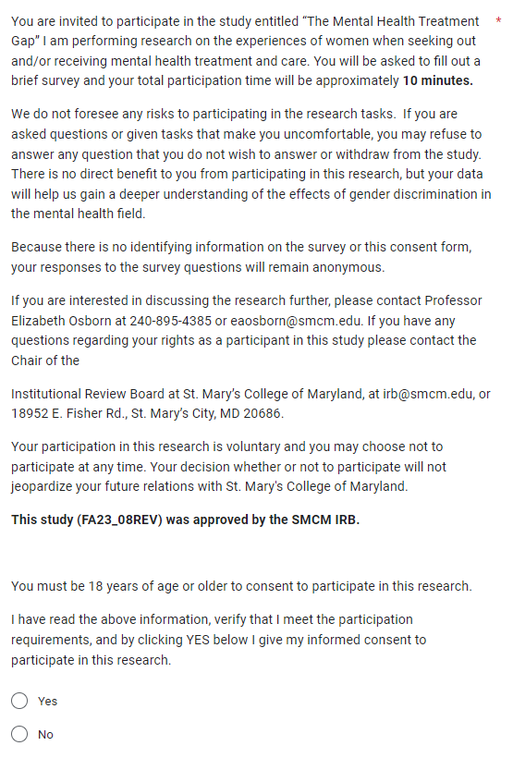

Example Entry Page with Consent Question (after answering a consent question, respondents are re-directed to the full survey, which is not hosted on Qualtrics)

This is how the survey landing page looks in Qualtrics:

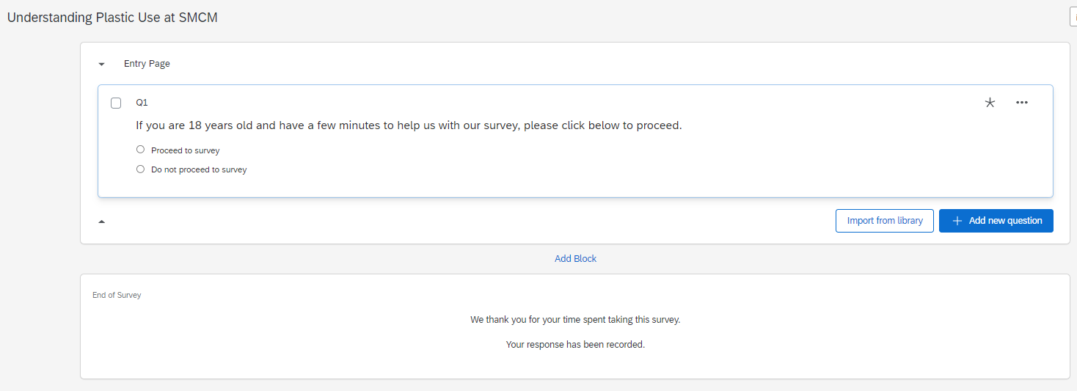

This is how the survey entry page appears to the respondent:

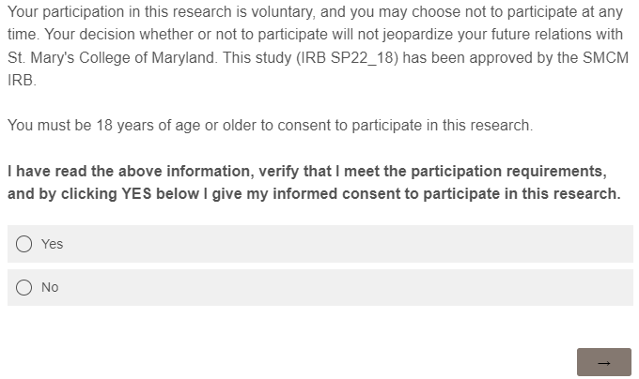

Example Entry Page Without Consent Question (Consent Question is displayed when respondent is re-directed to the linked survey)

This is how the survey landing page looks in Qualtrics:

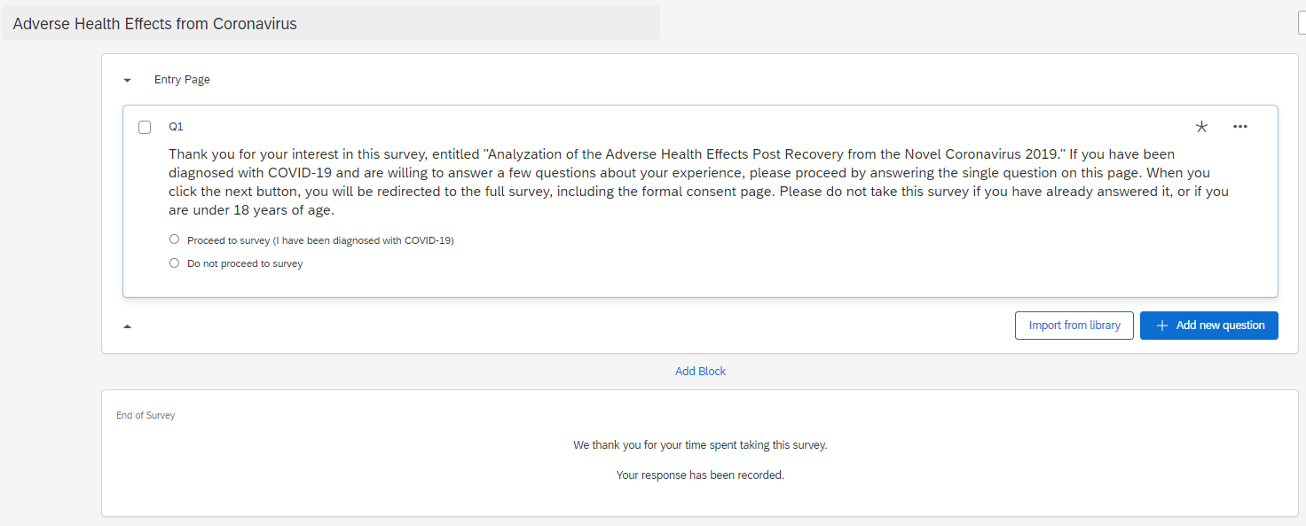

This is how the survey entry page appears to the respondent:
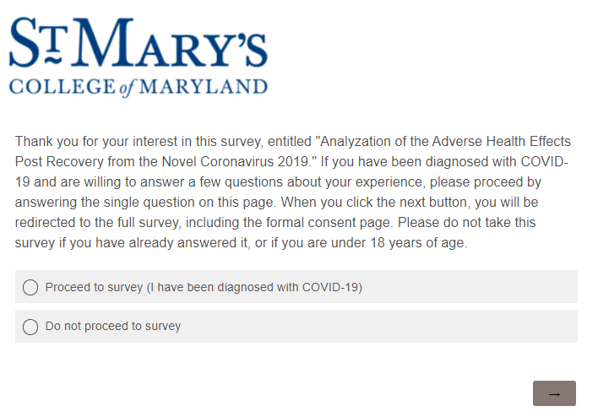

Example Email and Reminders Message Text

Use the text below as a guide to write your own email messages. You are encouraged to compose messages in your own voice, rather than follow the example word-for-word. Using your own voice can help avoid “survey fatigue,” which discourages participants from completing surveys that “all sound the same.” You do not have to include everything that is in these examples. An initial email message is required; up to 3 reminders are optional. The “Instructions” button shown in the examples below will be added automatically and will contain the link to the survey.

In addition to writing the text, please fill out the following information:

Item | Answer
Name of Sender:
Email of Sender:
Email Subject Line:
Date of Initial Email (Survey open date):
Number of Reminders (up to 3):
Date of Reminder 1 (optional):
Date of Reminder 2 (optional):
Date of Reminder 3 (optional):
Table 2. Requested information for email messages and reminders.
Note: Qualtrics only allows one “email of sender” in their messages, so for group projects, identify one person whose email will be listed.

Example initial email invitation (Thursday 3/7/19)
From: Samantha Martinson
Subject: Unknowns of Secondhand Smoke

You are invited to participate in the online study entitled, “The Unknowns of Secondhand Smoke.”

My name is Samantha Martinson, and for my Sociology Senior Seminar class, I am performing a survey to understand secondhand smoke and how people feel about their friends, family, or acquaintances who smoke and the effects they think it has on children. You will be asked to fill out 9 short survey questions related to secondhand smoke, and your total participation time will be approximately 2 minutes. Your data will help us understand secondhand smoke and how people feel about their friends, family, or acquaintances who smoke and the effects they think smoking has on children.

Your answers on the survey will be anonymous and not linked with your name or email address. You may have already completed the survey by clicking on a link from InsideSMCM. If you have already completed the survey, I thank you, and you do not need to fill it out again!

Thank you for your time,
Samantha

Example Reminder 1 (Monday 3/11/19)
From: Samantha Martinson
Subject: Unknowns of Secondhand Smoke

You are invited to participate in the online study entitled, “The Unknowns of Secondhand Smoke.”

My name is Samantha Martinson, and for my Sociology Senior Seminar class, I am performing a survey to understand secondhand smoke and how people feel about their friends, family, or acquaintances who smoke and the effects they think it has on children. You will be asked to fill out 9 short survey questions related to secondhand smoke, and your total participation time will be approximately 2 minutes. Your data will help us understand secondhand smoke and how people feel about their friends, family, or acquaintances who smoke and the effects they think smoking has on children.

Your answers on the survey will be anonymous and not linked with your name or email address. You may have already completed the survey by clicking on a link from InsideSMCM. If you have already completed the survey, I thank you, and you do not need to fill it out again!

Thank you for your time,
Samantha

Reminder 2 (Sunday 3/17/19)
From: Samantha Martinson
Subject: Unknowns of Secondhand Smoke

Welcome back from Spring Break! You are invited to participate in the online study entitled, “The Unknowns of Secondhand Smoke.” Please hurry - this survey will close at midnight on Sunday, March 24!

My name is Samantha Martinson, and for my Sociology Senior Seminar class, I am performing a survey to understand secondhand smoke and how people feel about their friends, family, or acquaintances who smoke and the effects they think it has on children. You will be asked to fill out 9 short survey questions related to secondhand smoke, and your total participation time will be approximately 2 minutes. Your data will help us understand secondhand smoke and how people feel about their friends, family, or acquaintances who smoke and the effects they think smoking has on children.

Your answers on the survey will be anonymous and not linked with your name or email address. You may have already completed the survey by clicking on a link from InsideSMCM. If you have already completed the survey, I thank you, and you do not need to fill it out again!

Thank you for your time,
Samantha

Reminder 3 (Final Reminder) (Sunday 3/24/19)
From: Samantha Martinson
Subject: LAST DAY - Unknowns of Secondhand Smoke

You are invited to participate in the online study entitled, “The Unknowns of Secondhand Smoke.” Please hurry - this survey is closing TONIGHT at midnight!

My name is Samantha Martinson, and for my Sociology Senior Seminar class, I am performing a survey to understand secondhand smoke and how people feel about their friends, family, or acquaintances who smoke and the effects they think it has on children. You will be asked to fill out 9 short survey questions related to secondhand smoke, and your total participation time will be approximately 2 minutes. Your data will help us understand secondhand smoke and how people feel about their friends, family, or acquaintances who smoke and the effects they think smoking has on children.

Your answers on the survey will be anonymous and not linked with your name or email address. You may have already completed the survey by clicking on a link from InsideSMCM. If you have already completed the survey, I thank you, and you do not need to fill it out again!

Thank you for your time,
Samantha

