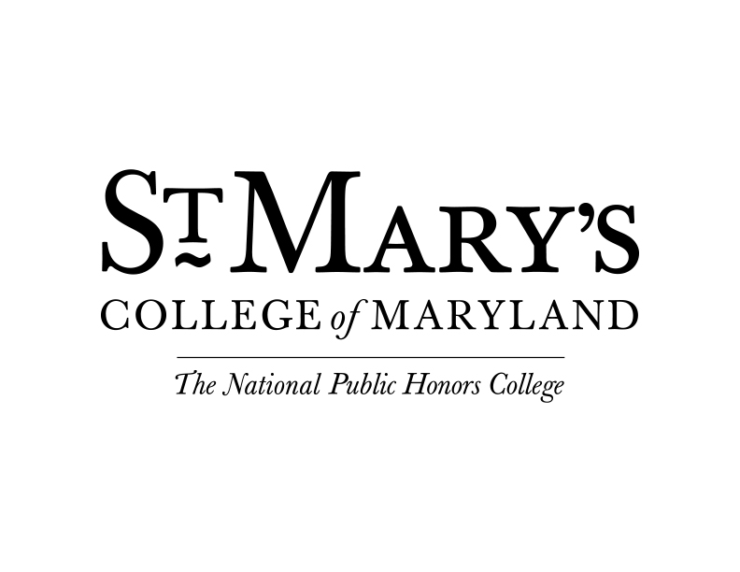

**Friday, January 10**

10:00 am-12:00 pm Residential Move-In | Residence Halls

Come to your assigned residence hall to begin the move-in process.

10:00 am-12:00 pm Technology Help | Office of Information Technology | Baltimore Hall

11:30 am-12:45 pm Continental Brunch | Dodge PAC Lobby

Take a break before the program begins and enjoy brunch at the Nancy R. & Norton T. Dodge Performing Arts Center. Families say goodbye.

12:00 pm-12:45 pm Commuter Students Orientation Check-In | Dodge PAC Lobby

For all new commuter students.

12:45 pm-1:00 pm Overview of Orientation and Goodbyes | Dodge PAC Lobby

For all new students & families.

1:00- 2:00 pm Welcome and Success at St. Mary’s College | Dodge PAC Recital Hall

Listen to campus community members as they share their experience and advice for incoming SMCM students. This is an opportunity to ask questions about the SMCM student experience and learn about the resources available to support your success in and out of the classroom.

2:30 - 3:30 pm Advising & Using the Student Portal

3:30 pm-4:30 pm Career Center Info Session | Dodge PAC Recital Hall

Meet the staff of the Center for Career and Professional Development and learn how they can prepare you for life after SMCM.

4:30pm-5:15 pm Residential & Commuter’s Meeting | Dodge PAC Recital Hall

Learn about the resources available to you that are unique to SMCM. Have your questions answered by a student staff member.

5:15 pm-6:00 pm Dinner | Great Room, Campus Center

Enjoy our Great Room with students with our OTeam. They love to talk about all things student and St. Mary’s College!

6:00 pm-6:45 pm Navigating Campus | Around Campus

6:45 pm Social | Learning Commons

After a day full of information overload, unwind with OTeam and your fellow new students. Join us for fun, games, and good company!

Saturday, January 11

12:00 pm-1:15 pm President’s Book Signing | Daughtery Palmer Commons

Meet Dr. Tuajuanda Jordan, president of St. Mary’s College of Maryland and sign the president’s book that has been signed by all students for over 40 years. Also enjoy brunch with your peers.

1:30 pm-2:30 pm Academic Success Session | Schaefer 106

Find out about the resources that successful Seahawks use, which include free tutoring, academic coaching and more.

2:30 pm-3:30 pm Bringing in the Bystander | Schaefer 106

This **mandatory** campus-wide in-person training will (in part) help to create a strong sense of community in which all members thrive and are successful.

3:30 pm-4:30 pm Diversity at SMCM | Schaefer 106

Learn what it means to be part of the St. Mary’s College community.

5:00 pm-6:00 pm Dinner | Great Room, Campus Center

Sunday, January 12

11:00 am-12:00 am Brunch | Great Room, Campus Center

12: 00 pm-1:30 pm Academic Building Tours | Around Campus

Get ready for the first day of class by touring the campus and learning where your classes are located.

3:30 pm - 5:00 pm Get Ready for First Day of Class | On Your Own

Prepare for the start of classes this week!

After, make your way to the Campus Center for your mailbox key.

5:00pm Dinner | Great Room, Campus Center

Finish off the long weekend with friends, food and our OTeam at dinner.