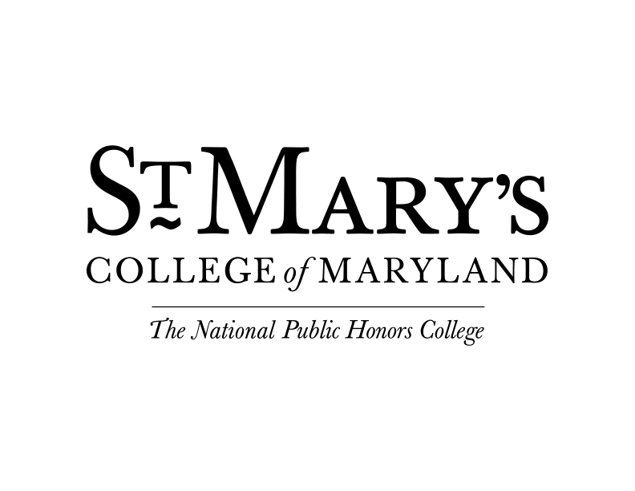

Saturday, January 17

10:00 a.m. -12:00 p.m. | Technology Help | Office of Information Technology | Baltimore Hall (Optional)
12:00 p.m. - 12:45 p.m. | Commuter Students Orientation Check-In | Dodge PAC Lobby  For all new commuter students.
12:15 p.m. - 1:00 p.m. | Continental Brunch | Dodge PAC Lobby  Take a break before the program begins and enjoy brunch at the Nancy R. & Norton T. Dodge Performing Arts Center.
1:00 p.m. - 2:00 p.m. | Welcome, Overview & Success at St. Mary’s College | Dodge PAC Recital Hall  Listen to campus community members as they share their experience and advice for incoming SMCM students. This is an opportunity to ask questions about the SMCM student experience and learn about the resources available to support your success in and out of the classroom. Parents say goodbye to your student.
2:00 p.m. - 3:00 p.m. | Supporting Your Student (Parents Session) | Dodge PAC Recital Hall
2:00 p.m. - 3:15 p.m. | Navigating Campus | Around Campus
3:30 p.m. - 4:30 p.m. | The Seahawk Standard | Learning Commons 111  Learn about the resources available to you that are unique to SMCM. Have your questions answered by a student staff member.
4:30 p.m. - 5:30 p.m. | Social | Learning Commons  After a day full of information overload, unwind with OTeam and your fellow new students. Join us for fun, games and good company!
5:30 p.m. - 6:30 p.m. | Dinner | Great Room, Campus Center  Enjoy our Great Room with other students and our OTeam. They love to talk about all things student and St. Mary’s College!

Sunday, January 18

12:00 p.m. - 1:15 p.m. | Lunch with the President | Daugherty-Palmer Commons  Meet Dr. Phillips, president of St. Mary’s College of Maryland and sign the president’s book that has been signed by all students for over 40 years. Also enjoy lunch with your peers.
1:30 p.m. - 2:00 p.m. | Advising & Using the Student Portal | Schaefer 106
2:15 p.m. - 3:30 p.m. | Student Success in Year 1 - First Year Students only | Schaefer 109
2:15 p.m. - 3:30 p.m. | Internships, Research & Grad School | Schaefer 106
3:35 p.m. - 4:00 p.m. | Bringing in the Bystander | Schaefer 106  This mandatory campus-wide in-person training will (in part) help to create a strong sense of community in which all members thrive and are successful.
4:00 p.m. - 4:30 p.m. | Inclusion & Belonging at SMCM | Schaefer 106  Learn what it means to be part of the St. Mary’s College community.
4:30 p.m. - 5:00 p.m. | Transfer Credit session | Schaefer 106
5:00 p.m. - 6:00 p.m. | Dinner | Great Room, Campus Center

Monday, January 19

8:00 a.m. - 10:00 a.m. | MLK Celebration (Optional) | Great Room, Campus Center
11:00 a.m. - 12:00 p.m. | Brunch | Great Room, Campus Center
12:00 p.m. - 1:30 p.m. | Academic Building Tours | Around Campus  Get ready for the first day of class by touring the campus and learning where your classes are located.
1:30 p.m. - 5:00 p.m. | Get Ready for First Day of Class | On Your Own  Prepare for the start of classes this week!
5:00 p.m. - 6:00 p.m. | Dinner | Great Room, Campus Center  Finish off the long weekend with friends, food and our OTeam at dinner.

