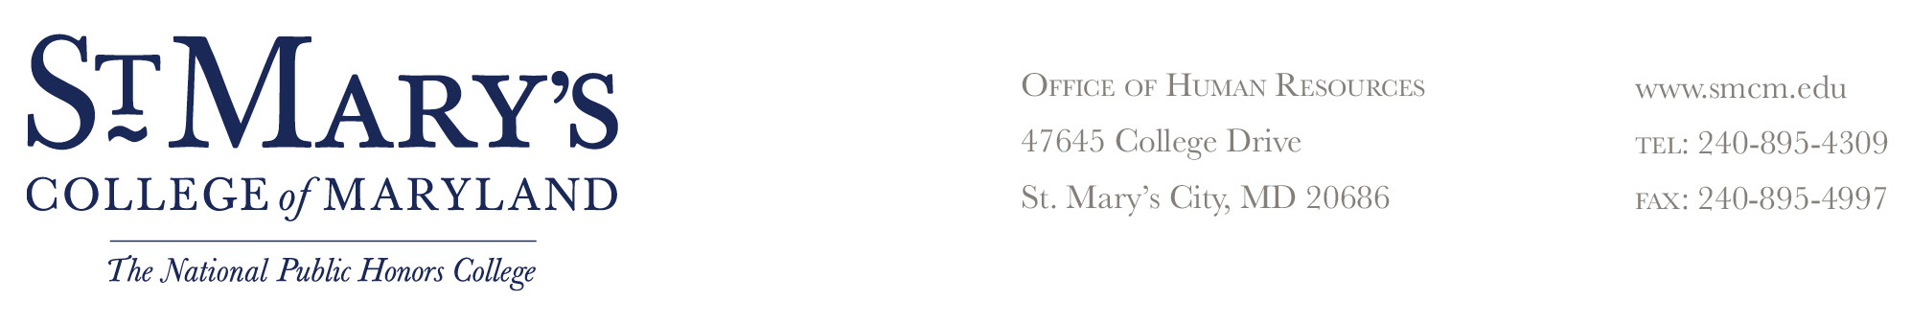
NOTICE OF END OF EMPLOYMENT

Date:

To Employee (Name): |  | Title:

Your employment will end effective (date) |  | (time) |  | .

Reason

Your employment is ending for violation(s) of a college rule(s) or regulation(s):

The violation(s) occurred on or about (date) |  |  |  |  | at approximately
(time) | . | at the following location

Facts Related to Violation (Be Specific Regarding Circumstances Involved)

Employees serving in a probationary status do not have the right to file a grievance; however, employees not in a probationary status may file a grievance with their shop steward within 10 working days from the date of the alleged incident or knowledge of incident.

Employee Received Original: _______________________________________
______ In Person Supervisor’s Signature Date
By Certified Mail
Title
_______________________________________
Employee’s Signature Date
My signature acknowledges receipt of this action; it
does not necessarily imply that I agree with the action.

