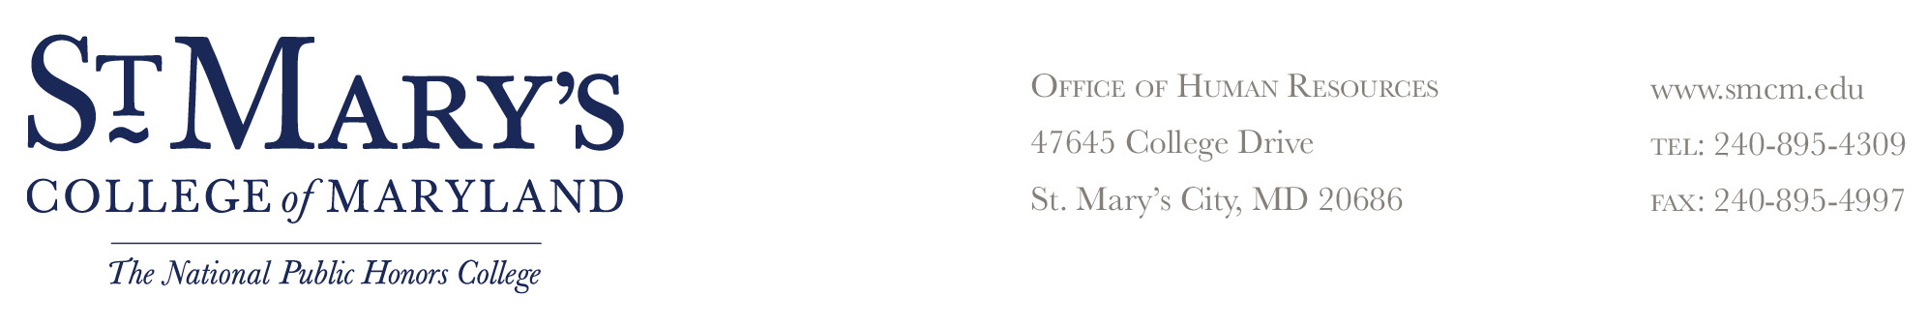

NOTICE OF DISCIPLINARY SUSPENSION

Date:

To Employee (Name): |  | Title:

Disciplinary Suspension

You are hereby suspended without pay for |  |  |  | work hours/ |  |  | work days
effective (date) |  |  | (time)
until (date) |  |  | (time)

Reason for Suspension

You are being issued this disciplinary suspension for violation of a college rule or regulation:

The violation occurred on or about (date) |  |  |  |  | at approximately
(time) |  | at the following location

Facts Related to Violation (Be Specific Regarding Circumstances Involved)

Future violations of college rules or regulations may result in further disciplinary action, suspension, or termination. Employee has the right to file a grievance with the Office of Human Resources within 10 working days from the date of the alleged incident or knowledge of incident.

Employee Received Original: _______________________________________
______ In Person Supervisor’s Signature Date
By Certified Mail
Title
_______________________________________
Employee’s Signature Date
My signature acknowledges receipt of this action; it
does not necessarily imply that I agree with the action.

