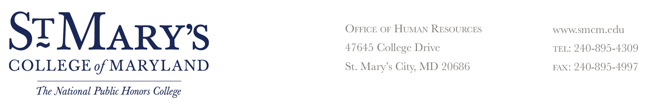

NOTICE OF DISCIPLINARY WARNING

Date:

To Employee (Name): |  | Title:

Reason for Warning

You are being issued this disciplinary warning for violation of a college rule or regulation:

The violation occurred on or about (date) |  |  |  |  | at approximately
(time) |  | at the following location

Facts Related to Violation (Be Specific Regarding Circumstances Involved)

Future violations of college rules or regulations may result in further disciplinary action that may result in suspension or termination. Employee has the right to file a grievance with the Office of Human Resources within 10 working days from the date of the alleged incident or knowledge of incident.

Employee Received Original: _____________________________
_____ In Person Supervisor’s Signature Date
_____ By Certified Mail
Title

_____________________________
Employee's Signature Date
My signature acknowledges receipt of this action; it
does not necessarily imply that I agree with the action.

