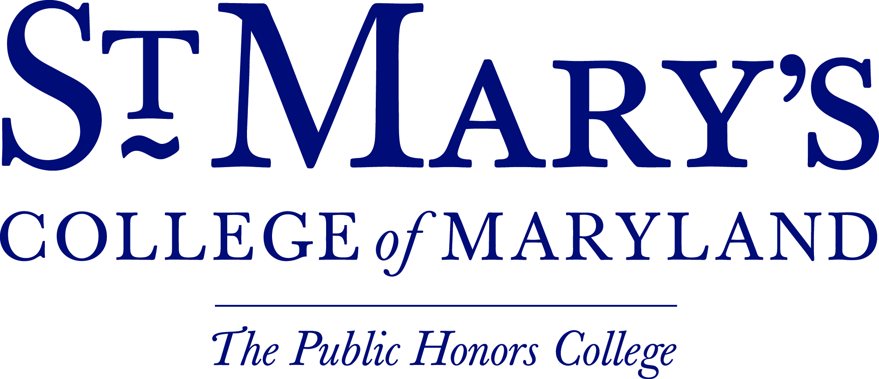
Institutional Animal Care and Use Committee (IACUC) Protocol Update Form

Federal and College Animal Assurance Policies require annual reporting on the status of your animal studies. To comply with these policies, please complete the following and submit to the IACUC chair at gmfernandez@smcm.edu. Any questions regarding this form or your current protocol should also be directed to the IACUC chair.

Protocol Number:
Protocol Year:
Investigator(s):

Is your protocol still active?
- Yes
- No If no, sign the next page and submit form

Animal Use Report: Please report the source and number of animals used during your active protocol . If you exceed the number of approved animals, a protocol modification must be submitted (see next page)

 | Year 1 | Year 2
Number of animals approved per protocol

Has the source of animals significantly changed since the original proposal or last amendment? If yes, please explain
 | - No  - Yes: | - No  - Yes:
Animal Housing Location
Total number of animals used in this reporting period

Have there been any changes in the animal component of the project (ex: change in the number of animal subjects, changing the route of administration of drugs), the additional of new personnel or changes to the sponsored funding mechanism?
- No
- Yes If yes, please explain:

If yes, please submit an Animal Use Protocol Amendment Request

Was there any unexpected reactions, spontaneous deaths, or basic problems with your protocol?
- No
- Yes If yes, please explain & detail how many animals were affected:

Please list any personnel changes, along with their qualifications:

Please sign and return this form to the IACUC Chair gmfernandez@smcm.edu

Signature Date

