Synthesis

What is Synthesis?
Synthesis refers to the process of combining ideas or information in order to draw a new conclusion. In other words, in order to perform synthesis, you must consider multiple ideas (usually from a variety of sources) simultaneously. After contemplating these ideas and the relationship between them, you derive a new idea or theory from them.

What does Synthesis look like in writing?
Writing that employs synthesis will usually:
- Discuss several sources of information at once instead of discussing each source individually
  - Some sources may still be discussed individually or separately from others. For example, sometimes you may only have one source on a certain part of your topic, so it might make since to discuss that source separately from others.
  - Just because you discuss sources simultaneously doesn’t mean that every source will be in every sentence or paragraph. For instance, you might find that you can divide your sources into groups based on some type of similarity such that you can discuss a few sources at a time instead of all of them at once.
- Draw new conclusions instead of simply repeating the conclusions in each source
  - The new conclusions you draw will be based on the conclusions or findings in each source, but they will still be new ideas.
- Avoid summary
  - Sometimes, it may be useful to summarize aspects of a source, but generally you would focus on the claims or findings of the source.

Synthesis Example 1 (Adapted from the blog Damndelicious.net):
Let’s say you find a nacho recipe online, and you want to know if it is a good recipe before you attempt it, so you start reading the comments and reviews on the recipe from other blog readers. You see this:
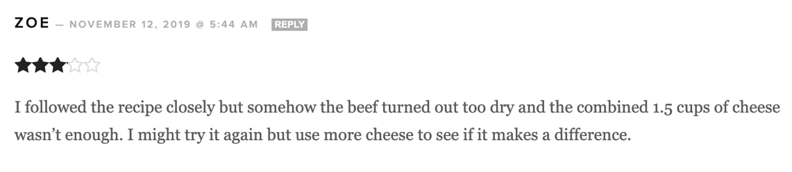

Based on just Zoe’s review (one source of information), you might decide that the recipe isn’t very good if the meat was dry and it didn’t call for enough cheese. But the nachos look delicious, so you decide to keep reading. You come across this review next:
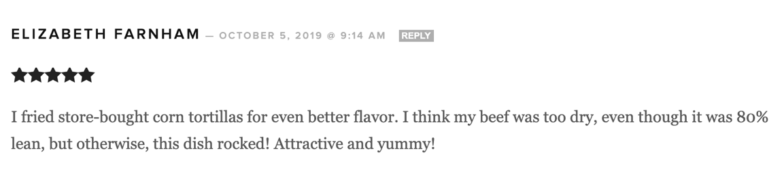

Now that you have read two reviews (and therefore have two sources of information), you’re now resigned to the fact that this recipe will produce dry meat. But, the second review didn’t mention an issue with the cheese ratio and otherwise rated the recipe highly. You have more hope for the recipe’s success now, but you still need to find a way to keep the meat from drying out, and the second review suggests that buying fattier meat won’t help. You decide to look at some more reviews:

Karen’s comment (your third source of information) suggests that she did not actually make the recipe
yet, but her question about adding water to the taco meat intrigues you. Could this be the solution to the problem with the meat drying out? You turn back to the reviews.

JamieJames’ comment (your fourth source of information) also mentions adding water, and it doesn’t mention any issues with dry meat. In fact, JamieJames used ground turkey, which would be far more likely to dry out than than the 80% lean ground beef Elizabeth used. And JamieJames didn’t mention needing more cheese, so that issue definitely seems to only be a problem for Zoe. You think you are ready to reach a verdict on the nacho recipe.

Based on your synthesis of four sources of information, you draw the following conclusion:

Although this is a good recipe, the nacho meat tends to dry out, so water must be added to the taco seasoning in order to prevent that issue.

Synthesis Example 2:
While you can synthesize information from similar sources (e.g., different reviews or ratings on the same recipe blog post), you can also synthesize information from dissimilar sources on the same topic. For example, let’s say you were writing a paper about parents’ involvement with their children’s homework and you didn’t need to use scholarly sources. First, you come across this tweet:

According to Audra McDonald’s tweet, parents might have forgotten the information they need to help
their kids with homework. Since this tweet is from the perspective of a parent, you decide to find a
different source from the perspective of a child. You find this cartoon:
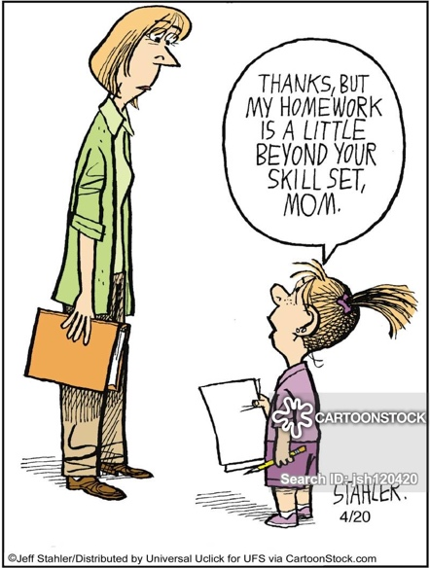

Based on this cartoon, children feel that their parents are unprepared to assist with homework.

After looking at the cartoon and the tweet, you synthesize the information in them to draw this new conclusion:

Although parents are generally willing to assist their children with homework, both parents and children often feel that parents are ill-equipped to help.

Synthesis Practice Activity:

Directions: Now that you have an idea of what synthesis is and how it works, you can try it on your own. Imagine you are researching single-sex classrooms in elementary and middle schools and that you have collected three journal articles on that subject.
- Read the following journal article excerpts. All of the excerpts are from the conclusions drawn by the article authors based on their research.
- For each excerpt, write a 1-sentence summary of the key points in the space provided.
- Reread all of the summaries you wrote and see if you can synthesize the information into a one sentence (in the space provided on the next page). Remember: your goal is to draw a new conclusion based on the information from all your sources.
- Try writing a paragraph (in the space provided on the next page) where the new conclusion you developed in step #3 is the topic sentence. Use information from the excerpts (quoting and citing when appropriate) to support your claim.

Excerpt #1:
“This research shows there have been positive benefits for children and teachers from single-sex classes in a coeducational primary school. Girls made considerable advances in the development of self-assurance and gained confidence to attempt new and demanding aspects of the curriculum. Boys made notable gains in their capacity for self-discipline and were motivated to engage enthusiastically with school work, and many developed a real commitment to participation in the school community. Teachers reported a high level of work satisfaction and expressed pleasure with the amount of time they now find themselves 'on task', 'actually teaching'-rather than dealing with behavioural infringements and emotionally distressed children” (Wills et al., 2006, p. 288).

One-Sentence Summary: ______________________________________________________________
____________________________________________________________________________________

Excerpt #2:
“Unless coeducational schools that implement boys-only classes to address a perceived educational need for boys encourage boys to critically reflect on gender, privilege and power, it is unlikely that these boys, or the girls they share school space with, are going to benefit from this structural reform”(Martino et al., 2005, p. 250).

One-Sentence Summary: ______________________________________________________________
____________________________________________________________________________________
Excerpt #3:
“For three years, a majority of single-sex sixth-grade girls in this study consistently expressed satisfaction with the single-sex environment, describing it as supportive and helpful. The resulting peer relationships allowed the girls to feel safe in asking others for assistance and to take risks in answering questions—risks they felt less secure about taking in coeducational classrooms” (Hart, 2016, p. 38).

One-Sentence Summary: ______________________________________________________________
____________________________________________________________________________________

Synthesize your summaries of the sources to form a new conclusion and record it in the space below. Your new conclusion should be 1-2 sentences.
____________________________________________________________________________________
____________________________________________________________________________________

Try writing a paragraph where the new conclusion you developed in step #3 is the topic sentence. Use information from the excerpts (quoting and citing when appropriate) to support your claim.
____________________________________________________________________________________
____________________________________________________________________________________
____________________________________________________________________________________
____________________________________________________________________________________
____________________________________________________________________________________
____________________________________________________________________________________
____________________________________________________________________________________
____________________________________________________________________________________
____________________________________________________________________________________
____________________________________________________________________________________
____________________________________________________________________________________
____________________________________________________________________________________

Bonus Round: Part of the point of synthesizing information is to identify gaps in your research (or in existing literature) or to identify new opportunities for research.

- If these three excerpts were the only literature available on same-sex education, what gaps exist in the authors’ findings?
______________________________________________________________________________________________________________________________________________________

- If these three excerpts were NOT the only sources if information on this subject, what else would you want to research on this subject? What new questions do you have?
______________________________________________________________________________________________________________________________________________________

