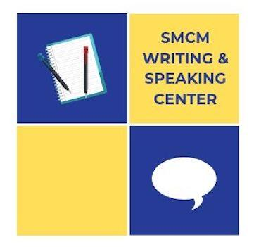
HOW TO SCHEDULE A TUTORIAL AT THE WRITING & SPEAKING CENTER

SCHEDULING INSTRUCTIONS
- Visit the Center’s website: www.smcm.edu/writingcenter
- Click the teal button that says “Schedule an Appointment” to access the Center’s Scheduler.
- On the Scheduler login page, login using your Center account credentials. If you do not already have an account, use the link on the login page to create one.
- After you login, follow directions at the top of the page to create an appointment.

SCHEDULING TIPS  - Consider strategy. Think about when in the process it makes sense to have a tutorial. Also, leave yourself time to revise after your session but before the assignment is due.  - Consider timing. Once you know when you want to make a tutorial, book the appointment. Otherwise, someone else may take your preferred time.  - Consider others. Please do not schedule in a way that interferes with other students using the Center. For example, avoid scheduling more appointments than you plan to attend, repeated rescheduling, etc. | WAYS TO PREPARE  - Ask your professor any questions you have about the assignment.  - Gather materials, including assignment guidelines, your draft, and instructor feedback.  - Prepare some questions for the tutor.
MAKING THE MOST OF TUTORING  • Tutoring is student-driven, so the tutor cannot help you unless you have questions or concerns in mind. If your tutorial is required, please make sure you know what you are supposed to work on in your tutorial.  • Tutoring is collaborative and emphasizes process over product. Tutors cannot make decisions or complete tasks for you, and they are not editors, but they can give you options to help you revise on your own. | CONTACT US  If you have difficulty scheduling an appointment or have questions,  please contact:  Dr. Ben Click  Director of the Writing & Speaking Center  baclick@smcm.edu

